Supplementary Data
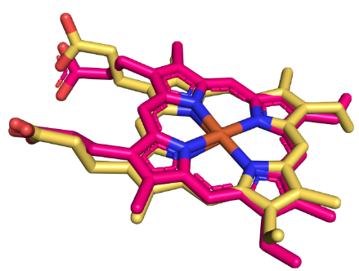
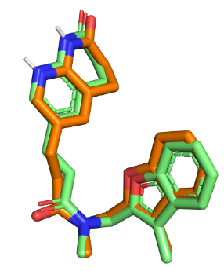
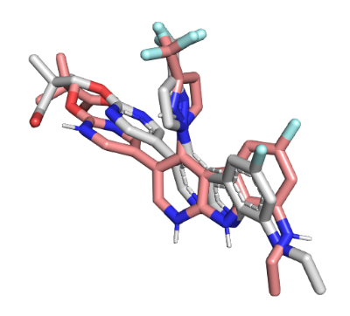
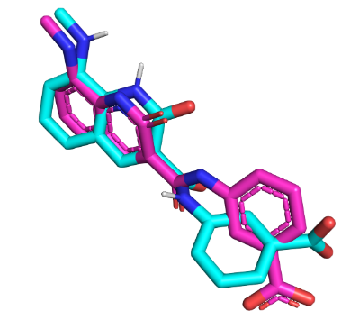
Co-6KZX (RMSD=1.780 Å)

Co-6M1S (RMSD=1.851 Å)

Co-4FS3 (RMSD=0.461 Å)

Co- 4UYL (RMSD=0.804 Å)

Figure. S1 Redocking validation of the docking protocol on the four ligand-bound targets 6KZX (E. coli GyrB), 6M1S (P. aeruginosa GyrB), 4FS3 (S. aureus FabI), and 4UYL (Aspergillus CYP51B homolog). Overlays show crystallographic ligands vs re-docked poses with RMSD values of 1.78, 1.85, 0.46, and 0.80 Å, respectively (all < 2.0 Å). The remaining receptors (4EWP, 5JLC, 1THG, 2W2K) were explored by blind docking.
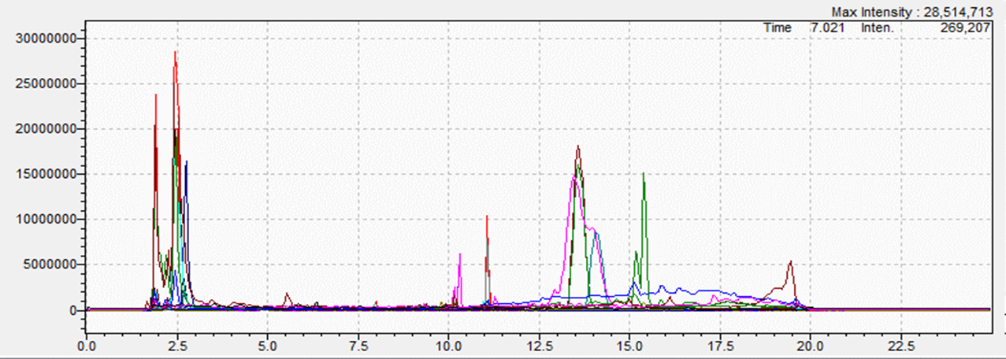
Figure S2: Chromatogram of acetone extract (ziziphus lotus) (ZLA)

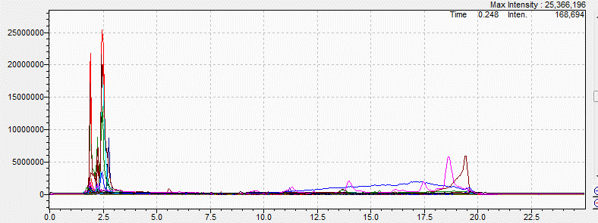
Figure S3: Chromatogram of methanol extract (ziziphus lotus) (ZLM)

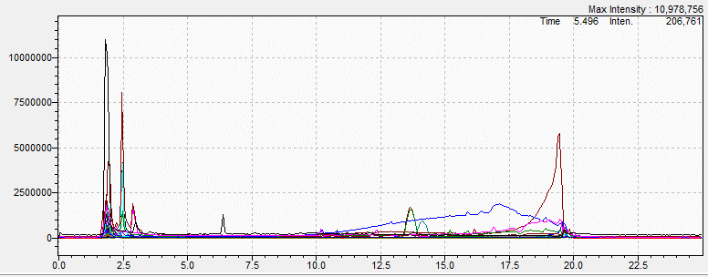
Figure S4: Chromatogram of acetone extract (ziziphus jujuba) (ZJA)

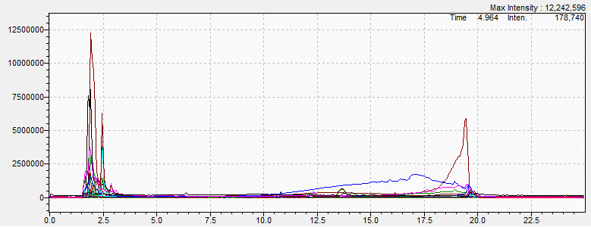
Figure S5: Chromatogram of methanol extract (ziziphus jujuba) (ZJM)

Table S1. TPC: Tukey’s multiple-comparison test (adjusted p-values)
Comparison | Δ Mean | p(adj) | Sig.
ZLA vs ZLM | 78.01 | 2.92 × 10⁻⁸ | ***
ZLA vs ZJA | 109.38 | 5.73 × 10⁻¹⁰ | ***
ZLA vs ZJH | 116.21 | 2.81 × 10⁻¹⁰ | ***
ZLA vs ZJM | 111.55 | 4.55 × 10⁻¹⁰ | ***
ZLA vs ZLH | 103.85 | 1.05 × 10⁻⁹ | ***
ZLM vs ZJH | 38.20 | 7.28 × 10⁻⁵ | ***
ZLM vs ZJA | 31.37 | 5.04 × 10⁻⁴ | ***
ZLM vs ZJM | 33.54 | 2.66 × 10⁻⁴ | ***
ZLH vs ZLM | 25.84 | 2.93 × 10⁻³ | **
ZLH vs ZJH | 12.36 | 0.400 | ns
ZLH vs ZJA | 5.53 | 1.000 | ns
ZLH vs ZJM | 7.70 | 1.000 | ns
ZJH vs ZJA | 6.83 | 1.000 | ns
ZJH vs ZJM | 4.66 | 1.000 | ns
ZJA vs ZJM | 2.17 | 1.000 | ns

Table S2. TFC: Tukey’s multiple-comparison test (adjusted p-values)
Comparison | Δ Mean | p(adj) | Sig.
ZJA vs ZLA | 19.36 | < 10⁻¹⁵ | ***
ZJA vs ZLM | 29.98 | < 10⁻¹⁵ | ***
ZJA vs ZJH | 30.31 | < 10⁻¹⁵ | ***
ZJA vs ZJM | 30.61 | < 10⁻¹⁵ | ***
ZJA vs ZLH | 31.16 | < 10⁻¹⁵ | ***
ZLA vs ZLM | 10.62 | < 10⁻¹⁵ | ***
ZLA vs ZJH | 10.94 | < 10⁻¹⁵ | ***
ZLA vs ZJM | 11.25 | < 10⁻¹⁵ | ***
ZLA vs ZLH | 11.80 | < 10⁻¹⁵ | ***
ZLM vs ZJH | 0.32 | 1.000 | ns
ZLM vs ZJM | 0.63 | 0.051 | ns
ZLH vs ZJH | 0.86 | 4.80 × 10⁻³ | **
ZLH vs ZLM | 1.18 | 2.62 × 10⁻⁴ | ***
ZLH vs ZJM | 0.55 | 0.110 | ns
ZJH vs ZJM | 0.30 | 1.000 | ns

